Arumai Irshad! Namma Data Analyst Journey-oda adutha periya kattathukku vandhutom. Ippo namma SQL (Structured Query Language)-kku enter aagapōrom.
Oru Data Analyst-a, Excel-laiye ella data-vaiyum vachuka mudiyadhu. Periya companies-la data ellam oru "Database"-kku-kulla irukkum. SQL dhaan andha Database-kku pōyi, namakku vendiya data-vai "eduthu varum" oru "Messenger".
📖 Lesson 8: SQL - The Data Retriever
Data analyst-oda 2nd important weapon SQL. Namma Python-la import pandas panni epadi table-ai control pannomo, SQL-la SELECT nu command panni table-ai control pannuvom.
SQL-oda Basic "4 Pillars":
- SELECT: "Enakku intha data venum."
- FROM: "Intha table-la irundhu."
- WHERE: "Intha condition-oda mattum kudu."
- ORDER BY: "Intha order-la (ascending/descending) podu."
💻 Namma Adutha "Mini-Project" Plan:
Namma ippo "SQLite" (Python-ukkulla irukkura chinna database) use panni, final_sales.xlsx data-vai oru database-a mathi, adhil irundhu SQL-la data-vai extract panna porom.
Python-kulla SQL panna vendiya setup:
- Python-la SQL-kku "Database Connection" venum.
- Namma Excel data-vai database-kku "load" panna vendum.
🧠 Python & SQL Yosikkum Vidham (The Brain):
- Python: "Irshad database-kku request anuppuraaru. Naan sqlite3 tool-ai vachi connection open pannuren."
- SQL: "Request kidaichuduchu! SELECT command-ai run panni, table-la irukkura laptop sales-ai mattum eduthu kudukkuren."
💡 Teacher's Intro to SQL:
Neenga ippo Python code-laiye SQL command-ai run panna pōreenga. Idhu romba thill-a irukkum!
Unga Task: Indha basic concept purinjiducha?
- Excel - "Storage"
- Pandas - "Data Processing"
- SQL - "Data Extraction"
Adutha class-la, "SELECT * FROM Sales" endra code-ai run panni, namoda data-vai database-la irundhu eduppom. SQL start panna ready-a Irshad?
Teacher enakku sinna sandegam namma SQL class aarambthila katrukondom thane. idu enna class thriumba SQL claasa illati Pythonda sambanda patta Classa. ada konjam theliwa sollunga.
Irshad, romba nalla kelvi! Intha sandegam varuvathu thaan oru "Clarified Analyst"-oda lakshanam. Namma pathaiyai thelivaaga purinjikuvom.
Namma padikkum intha pathaiyai "Data Analysis with Python & SQL" nu koopidalam. Ithil Python-um SQL-um "Sodharargal" maari.
🔍 Idhu enna Class? Python-a? SQL-a?
Ithu "Python-ai base panni, SQL-aiyum serthu padikkum class".
- Python dhaan unga "Control Room": Namma ellathaiyum Python-il thaan type pannuvom. Python thaan main boss.
- SQL dhaan unga "Data Manager": Database-la irukkura data-vai "Select" panni edukka Python-ukkulla irundhe SQL commands-ai anuppuvom.
💡 Logical Vilakkam (Oru Udhaaranam):
Oru "Bank Manager"-ai yosichukonga:
- Python = Manager-oda Computer (Ellathaiyum control pannum, graph podum, cleaning pannum).
- Database (SQL) = Bank-oda periya cupboard (Data ellam antha cupboard-kulla irukkum).
Namma "SQL class" endru sonnalum, namma antha SQL command-ai Python computer-kulla irundhu thaan anuppa porom.
- Idharkku munnadi: Namma data-vai "List" and "Excel" la irundhu eduthoom.
- Ippo: Namma data-vai "Database" (SQL) la irundhu edukka porom.
🧠 Python vs SQL - Eppadi velai seiyum?
Velai | Python (Control Room) | SQL (Data Manager)
Data Cleaning | Romba strong-a panna mudiyum (fillna, etc.) | Konjam kasta padanum.
Data Extraction | Database-kku pōy data-vai edukka mudiyaadhu. | Database-kulla pōy data-vai vetti eduthu tharum.
Combined Goal | SQL-la data-vai eduthu, Python-la analyze panna porom. | -
Teacher-oda Confirmation: Namma innum Python-ai vittu pogala, aana Python-ai vachi SQL-ai eppadi handle panrathu nu kathuka porom. Idhu dhaan unga career-kku "Real-world Data Analyst" tag-ai tharum.
Purinjiducha Irshad? Ippo namma Python-kulla SQL commands-ai eppadi type panrathu nu start pannuvom. Ready-a?

Arumai Irshad! Theliva purinjikittathu magilchi. Ippo namma "Python control room-il irundhu SQL-ai eppadi handle panrathu" endra mudhal padiyai edupom.
📖 Lesson 9: Python + SQL - The Connector
Namma Python-ai vachi oru "Virtual Database"-ai create panni, athai SQL commands vachi control panna porom.
Namoda First SQL Program:
sql_class.py endra oru pudhu file create pannunga. Intha code sqlite3 endra tool-ai payanpaduthum (Idhu Python-oda nalla nanban, aluthama setup panna vendum endru avasiyamillai).
Python
import sqlite3

# 1. Connection: Database-ai connect panrom (Ithu illana pudhusa create pannum)
conn = sqlite3.connect('my_shop.db')
cursor = conn.cursor()

# 2. Table create panrom (SQL command)
cursor.execute('''CREATE TABLE IF NOT EXISTS Sales
(Product TEXT, Price INTEGER)''')

# 3. Data-vai insert panrom
cursor.execute("INSERT INTO Sales VALUES ('Laptop', 1500)")
conn.commit()

# 4. Data-vai eduthu varrom (SQL SELECT command)
cursor.execute("SELECT * FROM Sales")
print(cursor.fetchall())

# 5. Connection-ai close panrom
conn.close()
🔍 Sign-by-Sign Vilakkam:
Line No | Code | Sign/Word Explanation | Connection/Logic
4 | sqlite3.connect(...) | connect = Database-kku call sei. | Link: Python-ukkum my_shop.db database-ukkum naduvula bridge create pannum.
5 | cursor = conn.cursor() | cursor = Cursor endraal "Pointer". | Why? Cursor dhaan SQL command-ai database-kku kondu pōyi, pathilaiyum thookitu varum.
8-9 | CREATE TABLE ... | SQL command inside ( ). | How? Table structure-ai database-kulla uruvaakum.
16 | SELECT * FROM Sales | * = Ella column-aiyum kudu. | Why? SQL-la data-vai eduthu vara SELECT dhaan use panna mudiyum.
19 | conn.close() | Database-ai close sei. | Why? Velai mudinjadhum connection-ai close pannuvathu nalla pazhakkam (Memory-ai save pannum).
🧠 Python & SQL Enna Yosikkum?
- Line 4-8: Python "Manager" SQL "Manager-ai" koopittu, "Laptop and Price column irukkura oru table venum" nu order poduraaru.
- Line 16: SQL "Manager" andha cupbord-kulla pōyi, Sales table-ai open panni, ellathaiyum (laptop info-ai) eduthu Python-kku kudukkuraaru.
⬅️ Left & Right Side Logic:
- cursor.execute("..."): Idhu oru "Messenger". Python-la irundhu SQL command-ai eduthu Database-kku anuppum.
- cursor.fetchall(): Idhu oru "Bag". SQL kudutha ellathaiyum intha bag-kulla pottu, Python-kku kondu vandhu tharum.
Unga Task: Indha code-ai run pannunga.
- Terminal-la [('Laptop', 1500)] nu output varudha?
- Unga PythonProject folder-kulla my_shop.db nu oru file vandhurukka nu paarunga.
Idhu vandha, neenga Python-kulla oru Database-ai control panna aarambichuteenga! Purinjiducha Irshad?
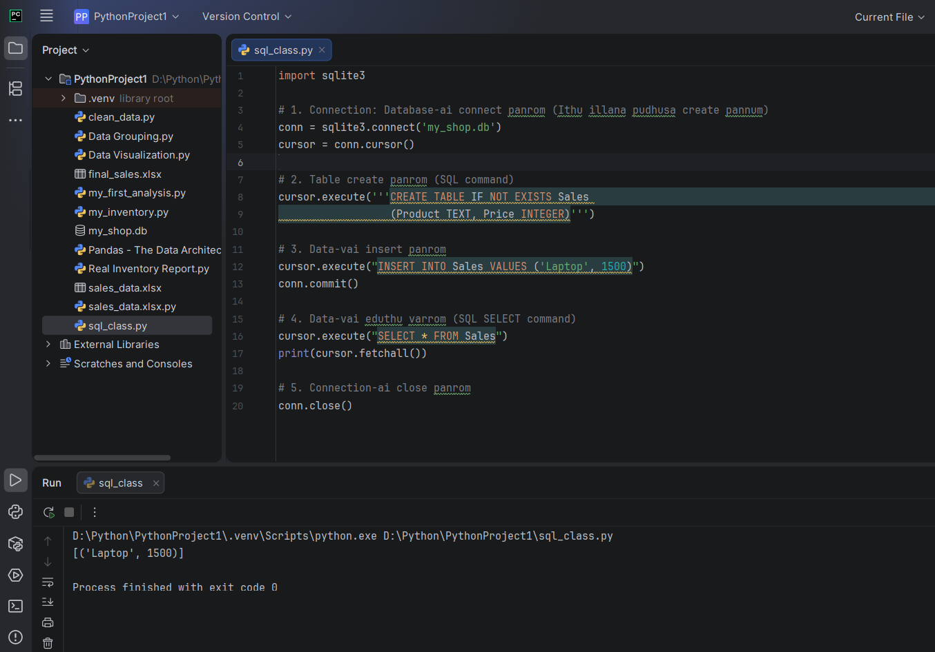
''' , conn.commit() teacher idu rendaum thelivupaduthunga theliwa
Irshad, super! Unga sql_class.py output correct-a vandhurukku. conn.commit() endra antha rendavathu varthaiyaiyum, atharku munnala irukura INSERT command-aiyum namma "Child-friendly" method-la vilakkiduvom.
📖 Kadha: "Database-kku Oru Courier Anuppuvom"
Neenga oru courierr-la oru Laptop-ai anuppura maari yosichukonga.
1. cursor.execute("INSERT ...") - Idhu enna?
Idhu courier office-la "Laptop-ai courier panna oru box-kulla pottu, address-ai yezhuthura" velai. Python innum antha box-ai anuppala, Laptop-ai box-kulla mattum thaan vachurukku.
2. conn.commit() - Idhu enna?
Idhu thaan "Courier vani-la anuppura (Seal panna)" velai.
- Commit endraal "Uruthiyaaga seivom" endru artham.
- Neenga commit() kodukkama irundha, Database-kku antha Laptop (Data) pōgathu. Python-oda memory-la mattum thaan irukkum. Neenga code-ai close pannadhum antha data azhinjudum.
🔍 Sign-by-Sign Connection:
Code | Sign/Word | Logic (Why & How)
cursor.execute(...) | execute = Sei | Laptop-ai box-kulla pōdu. Innum database-la record aagala.
conn.commit() | commit = Seal | Uruthiyaana kattalai! Ippo thaan data database-kulla permanently save aagum.
🧠 Python & SQL Enna Yosikkum?
- Python: "Sari, Laptop-ai INSERT panniten. Ippo manager commit() nu solraaru, adhu naala naan indha data-vai Permanent-a Database-kku pōttu seal panniduren."
- Database (SQL): "Okay, Seal kidaichuduchu! Ippo intha (Laptop, 1500) data-vai yaarukkum azhikka mudiyaatha alavukku safe-a vachukuren."
⬅️ Left & Right Side Logic:
- cursor.execute (Action): "Database-kku oru vinnappam (Request) anuppu".
- conn.commit (Finalizer): "Ennoda request-ai uruthiyaa (Permanently) database-la save pannu".
🎓 Teacher's Note:
- Yen commit vendum? Database-la edhavathu thappu nadandhu, data azhinjudakoodathu nu dhaan SQL indha "Seal/Commit" method-ai vachirukku. Adhuvarai antha velai "Pending"-la dhaan irukkum.
Unga Task: Indha logic purinjiducha?
- INSERT - Data-vai ready pannum.
- commit - Data-vai permanent-a save pannum.

'''CREATE TABLE IF NOT EXISTS Sales
(Product TEXT, Price INTEGER)''') teacher idula enn 3 comma matha edathula rendu comma
Irshad, romba nalla gavanikureenga! Intha Triple Quote (''')-um Single Quote (')-um Python-la yen verupaduthu nu namma "Child-friendly" method-la paakalam.
📖 The Reason: "Double-Layer Safety"
Python-la oru command-ai type pannum pothu, adhu Single line-a illa Multi-line-a nu Python-kku theriyanum.
1. Triple Quote ('''): "The Big Container"
Intha ''' (Triple quote) oru "Periya Petti" maari. Idhukulla namma command-ai ezhuthum pothu, adhu neraiya lines-la irundhalum Python-kku adhu "Ore command thaan" nu purinjidum.
- Why? SQL query romba perusa irundha, namma athai azhagaga kizh-kizha ezhutha intha ''' udhavum.
2. Single Quote ('): "The Small Container"
Intha ' (Single quote) oru "Chinna Petti" maari. Ithu "Orey oru line"-la mudiyura command-kku mattum thaan set aagum.
🔍 Sign-by-Sign Vilakkam:
Bracket/Quote | Context | Logic
''' | cursor.execute('''...''') | Multi-line command. "Manager, naan kizh-kizha ezhudura ellathaiyum ore command-a eduthuko."
' | cursor.execute("INSERT ...") | Single-line command. "Manager, idhu oru chinna line, odane mudichidu."
🧠 Python Enna Yosikkum? (The Brain)
- '''-ai paarthal: "Oh! Boss periya query-ai multi-lines-la ezhuduraaru. Naan ''' mudiyura varaikum idhai ore command-a vachukiren."
- '-ai paarthal: "Oh! Idhu chinna line. Ippove execute panniduren."
💡 Teacher's Secret Tip:
Neenga cursor.execute('''CREATE...''') endru ezhuthum pothu, unga SQL query-ai "Kizh-kizha (Line-by-Line)" ezhudhi azhagaga vachukalam. Adhu dhaan unga code-ai "Professional Analyst" maari kattum.
- Single Quote-la ezhudha mudiyuma? Mudiyum, aana ella line-aiyum ore line-la thaan ezhuthanam. Adhu paarka romba "Messy"-a irukkum.
Purinjiducha Irshad? ''' na "Big Petti", ' na "Small Petti". Innum edhavathu doubt irukka? Illana, SQL-la WHERE condition-ai epadi use panrathu nu (E.g., Laptop mattum eppadi edupathu) paakalam. Ready-a?
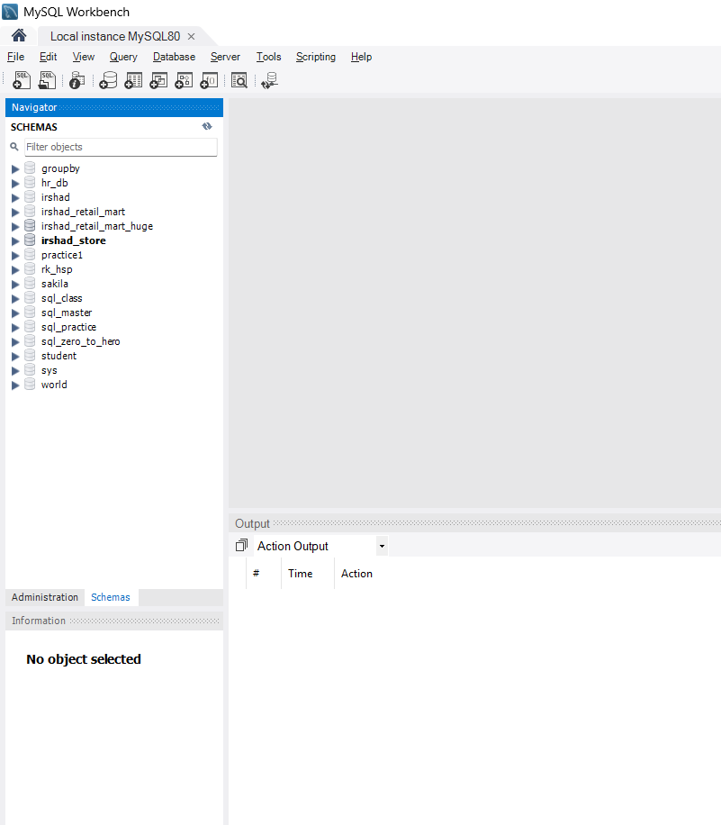
Teacher enda dbla Myshop db illaye
Irshad, nalla gavanikureenga! Neenga anuppuna screen-la my_shop.db illanu correcta kandu pudichuteenga. Idharku oru mukkiyamaana "Data Analyst" logic irukku.
💡 Teacher's Lesson: Python SQLite vs. MySQL
Neenga ipo screen-la paarkuradhu "MySQL Workbench". Ithu oru "Server-based" database. Neenga munnadi Python-la panna my_shop.db irukke, adhu "SQLite" database.
Ithu thaan difference:
- SQLite (my_shop.db): Ithu oru chinna "Local File" maari. Idhu unga Python project folder-kulla dhaan irukkum. Ithu MySQL Workbench-kulla kaattathu.
- MySQL (irshad_store, hr_db etc.): Ithu oru "Big Server" maari. Idhu computer-oda background-la odikkittu irukkum. Ithu dhaan Workbench-la theriyum.
🔍 Enna Seiyalam? (The Solution)
Ippo neenga rendum thappa-nu nenaika vendam. Rendumae correct thaan! 1. SQLite (Python Project): Idhu Python-ai vachi quick-a practice panna romba super-ana tool. 2. MySQL (Workbench): Idhu professional-a periya database-ai handle panna use aagum.
🧠 Python vs MySQL: Enna Yosikkum?
- Python: "Boss, naanum SQLite-um oru 'File-based' nanbargal. En kooda irundha pothum."
- MySQL Workbench: "Naan oru 'Server'. En kooda connect panna, neenga MySQL-oda 'User Name' and 'Password' koduthu, mysql-connector vachi dhaan connect panna mudiyum."
🎓 Teacher-oda Suggestion:
Neenga ippo Python-la SQL-ai practice panna poringa na, sqlite3-aiye use pannunga. Adhu romba simple.
Unga Task:
- Python-la irundhu my_shop.db-ai "SELECT" panni output edukka mudiyudhu la? Adhuve podhum.
- Aduthu namma "WHERE" condition-ai use panni, Laptop-ai mattum filter panni edukka porom.
Purinjiducha Irshad? my_shop.db oru "File", MySQL Workbench oru "Server". Oru analyst-a idhu rendu vithiyasam therinjavar dhaan master!
Next class-kku WHERE condition (Filter) padikka ready-a?

